**INFORMATION GATHERING USING HARVESTOR**

**Aim:**

To demonstrate information gathering using theHarvester

**Procedure:**

**STEP 1: Open Terminal in the kali linux**

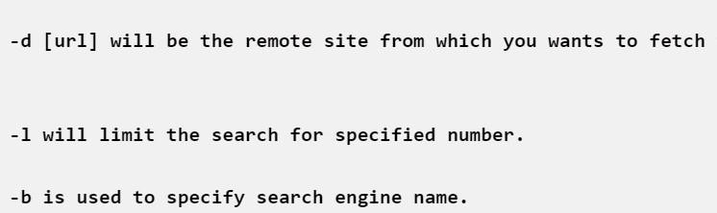

**STEP 2: Run the following command**

**Command: theHarvester -d** [**www.zoho.com**](http://www.zoho.com/) **-l 300 -b all**

Step 4: run this command “**theHarvester -d** [**www.zoho.com**](http://www.zoho.com/) **-l 300 -b all -f test” and** hit enter to export the result as html file and xml file

Step 5: now close the terminal and navigate the home folder and search for test file .

**OUTPUT:**

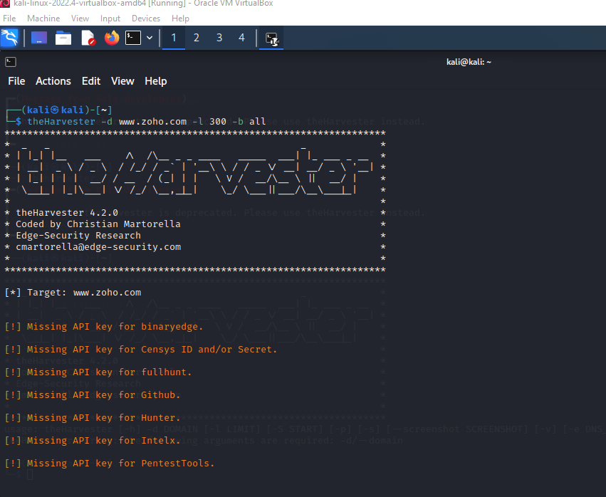

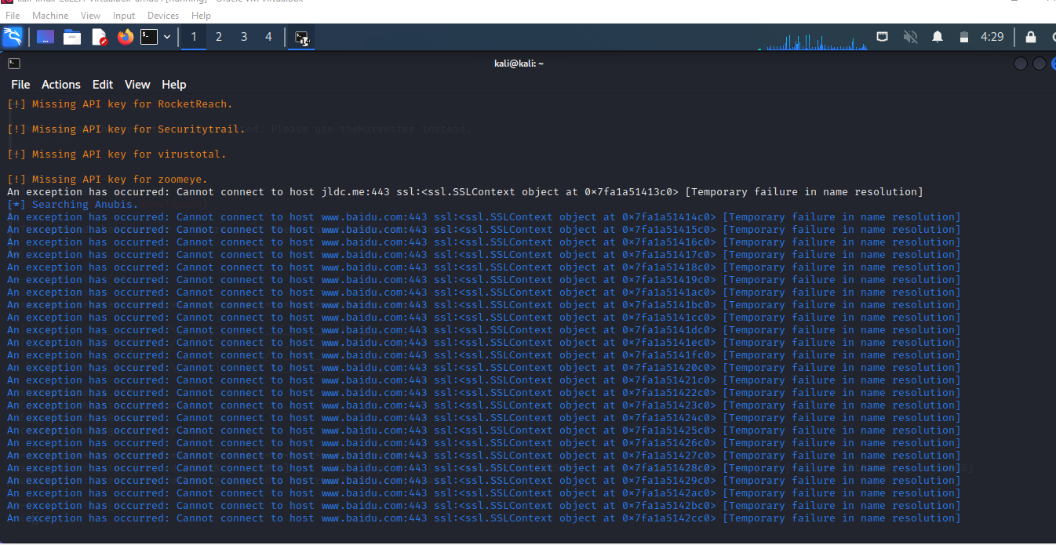

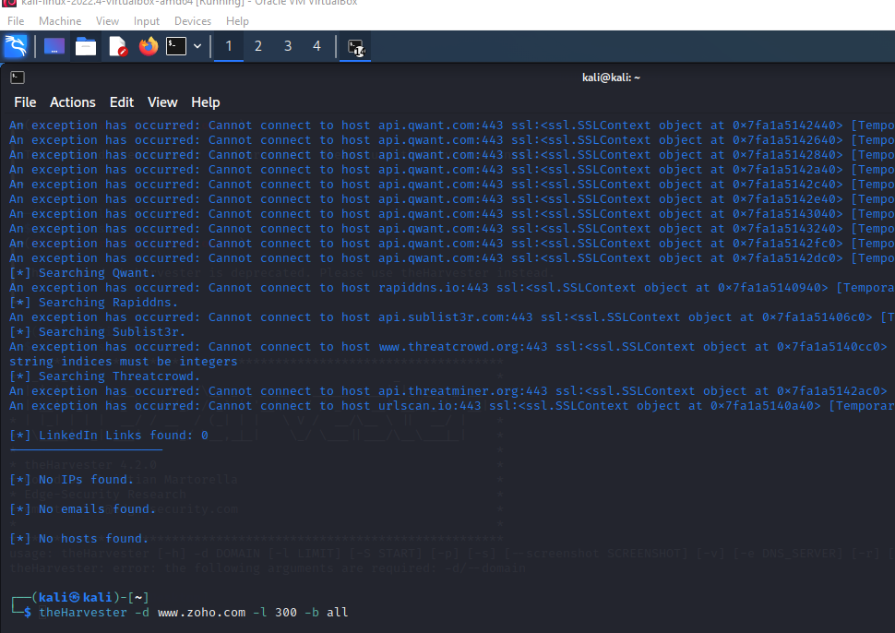

**Result:**

Hence we have demonstrate information gathering using harvester successfully.